Product Management Log

Product management discussion

As of present, the group is working very well. This is evident as all members of Team 3 feel that we are all well integrated into the group. Due to this, it means that communication within the team is very sufficient. At first there was a lack of team meetings, however as time has progressed we have all gelled together. Each member has their own strengths which has meant that the project is excelling due to the different contributions from each individual. Planning for the project has been excellent as the workload has been divided among each other fairly evenly, with specific tasks being assigned to align with the strengths of each member, this can be seen throughout the most recent Sprint in Jira.   
 In general Scrum meetings are very efficient as all members are all present, it has meant that any issues with the project are easily discussed and that resolutions are quickly found from the support of each other. As the meetings are already at a high efficiency, there is not much to improve on. However as a group we feel that due to other module assignments / tests it has prevented us from increasing more productivity for the project via more meetings or increased meetings times (Generally meetings have been held for 2 hours, weekly. )  
 There have not been any communication issues as of present, this is due to the use of the Jira system and also the notifications and updates we receive via Email when a member has made any changes to a task or issue from the backlog.   
 As of current there have not been any stand up meetings as the group is progressing well with the product.

Sprint Burndown Charts

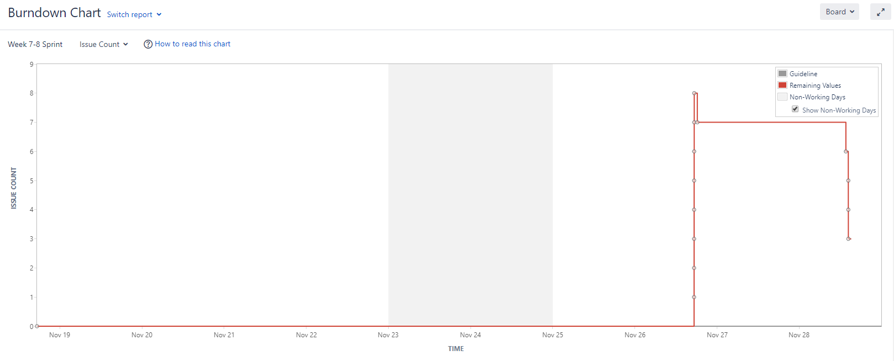

Product Backlog

